

**IBM APP CONNECT INSTALLATION (V 11)**



**Table Contents:-**

1. **Steps to install IBM ACE**

**Step 1:** Get the IBM ACE version to be installed.



**Step 2:** Accept the license, after reading terms and conditions.

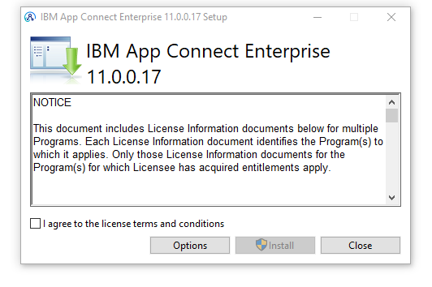

**Step 3:** Select installation types.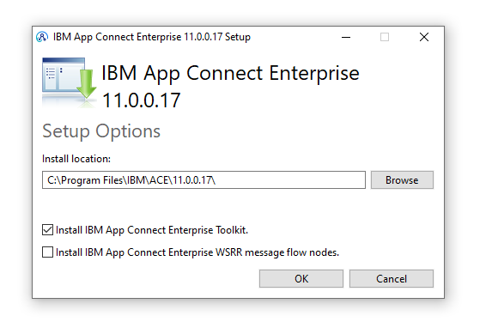

**Step 4:** Click on install (installation progress starts).

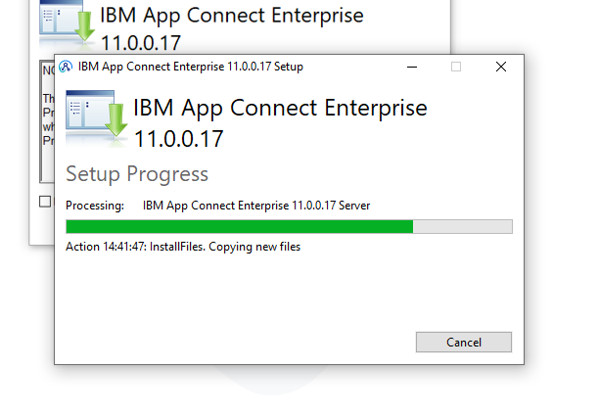

**Step 5:** IBM ACE v 11 installed.

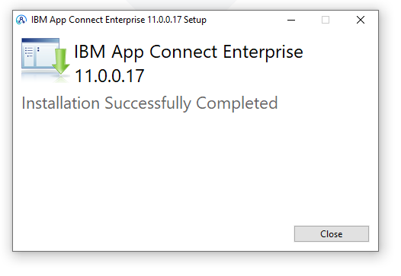

**Step 6:** IBM ACE opens, select the workspace.

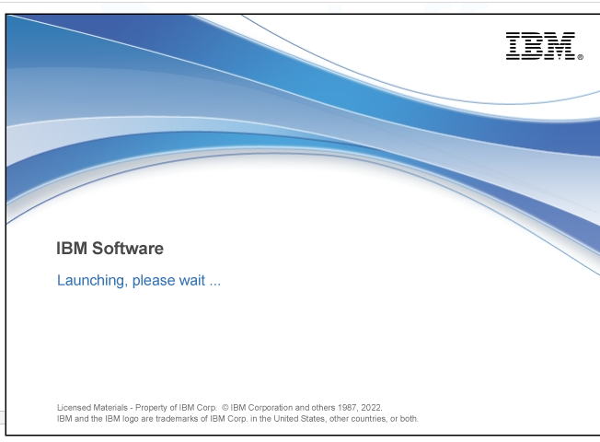

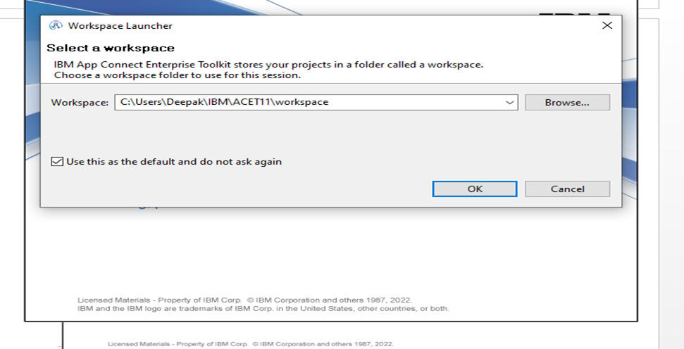

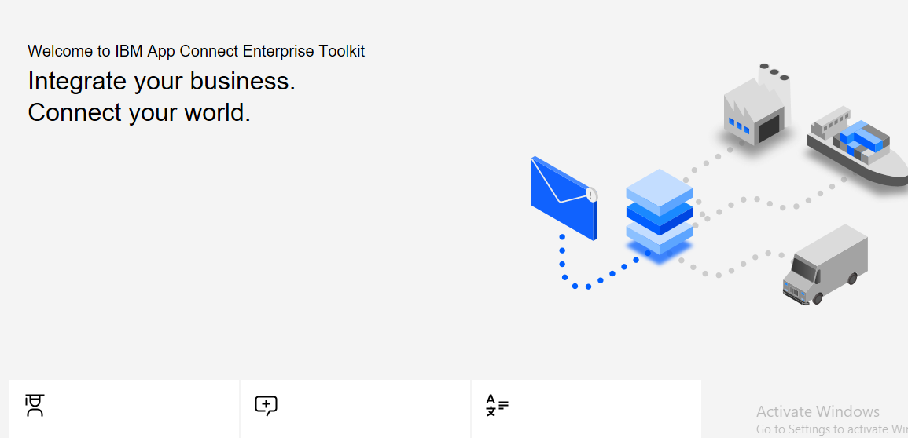

**Step 7:** Ready to use IBM ACE

